Natural language processing (NLP) is an area of artificial intelligence (AI) aimed at teaching computers to understand written and verbal human language and interact with humans by using such a language. Whilst traditional NLP methods have been studied for decades, the recent emergence of large language models (LLMs) has virtually taken over all developments in the field. By combining sophisticated deep learning architectures with the self-attention mechanism capable of analyzing complex patterns and interdependences in language, LLMs have revolutionized the field of NLP and AI as a whole, due to the wide range of language generation and language understanding tasks they can address and their range of applications: conversational chatbots, in-depth document analysis, translation, and more.
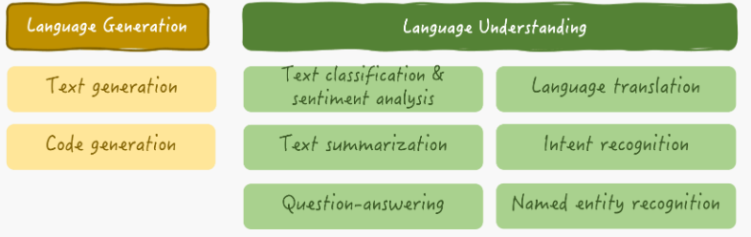

LLM Capabilities and Limitations
The largest general-purpose LLMs launched by major AI firms, such as OpenAI’s ChatGPT models, Gemini models from Google mainly specialize in language generation, that is, given a prompt — a query, question, or request formulated by a user in human language — the LLM must produce a natural language response to that prompt, generating it word by word. To make this seemingly arduous task possible, LLMs are trained upon extremely vast datasets consisting of millions to billions of text documents ranging from any topic(s) you can imagine. This way, LLMs comprehensively learn the nuances of human language, mimicking how we communicate and using the learned knowledge to produce “human-like language” of their own, enabling fluent human-machine communication at unprecedented levels.
There’s no doubt LLMs have meant a big step forward in AI developments and horizons, yet they are not exempt from their limitations. Concretely, if a user asks an LLM for a precise answer in a certain context (for instance, the latest news), the model may not be able to provide a specific and accurate response by itself. The reason: LLMs’ knowledge about the world is limited to the data they have been exposed to, particularly during their training stage. An LLM would normally not be aware of the latest news unless it keeps being retrained frequently (which, we are not going to lie, is an overly expensive process).
What is worse, when LLMs lack ground information to provide a precise, relevant, or truthful answer, there is a significant risk they may still generate a convincing-looking response, even though that means formulating it upon completely invented information. This frequent problem in LLMs is known as hallucinations: generating inexact and unfounded text, thereby misleading the user.

Why RAG Emerged
Even the largest LLMs in the market have suffered from data obsolescence, costly retraining, and hallucination problems to some degree, and tech giants are well aware of the risks and impact they constitute when these models are used by millions of users across the globe. The prevalence of hallucinations in earlier ChatGPT models, for instance, was estimated at around 15%, having profound implications for the reputation of organizations using them and compromising the reliability and trust in AI systems as a whole.
This is why RAG (retrieval augmented generation) came onto the scene. RAG has unquestionably been one of the major NLP breakthroughs following the emergence of LLMs, due to their effective approach to addressing the LLM limitations above. The key idea behind RAG is to synthesize the accuracy and search capabilities of information retrieval techniques typically used by search engines, with the in-depth language understanding and generation capabilities of LLMs.
In broad terms, RAG systems enhance LLMs by incorporating up-to-date and truthful contextual information in user queries or prompts. This context is obtained as a result of a retrieval phase before the language understanding and subsequent response generation process led by the LLM.
Here’s how RAG can help addressing the aforementioned problems traditionally found in LLMs:
- Data obsolescence: RAG can help overcome data obsolescence by retrieving and integrating up-to-date information from outer sources so that responses reflect the latest knowledge available
- Re-training costs: by dynamically retrieving relevant information, RAG reduces the necessity of frequent and costly re-training, allowing LLMs to stay current without being fully retrained
- Hallucinations: RAG helps mitigate hallucinations by grounding responses in factual information retrieved from real documents, minimizing the generation of false or made-up responses lacking any truthfulness

The Classic RAG Workflow
A typical RAG system (depicted in the diagram below) handles three key data-related components:
- An LLM that has acquired knowledge from the data it has been trained with, typically millions to billions of text documents.

- A vector database, also called knowledge base storing text documents. But why the name vector database? In RAG and natural language processing (NLP) systems as a whole, text information is transformed into numerical representations called vectors, capturing the semantic meaning of the text. Vectors represent words, sentences, or entire documents, maintaining key properties of the original text such that two similar vectors are associated with words, sentences, or pieces of text with similar semantics. Storing text as numerical vectors enhances the system’s efficiency, such that relevant documents are quickly found and retrieved.

- Queries or prompts formulated by the user in natural language.

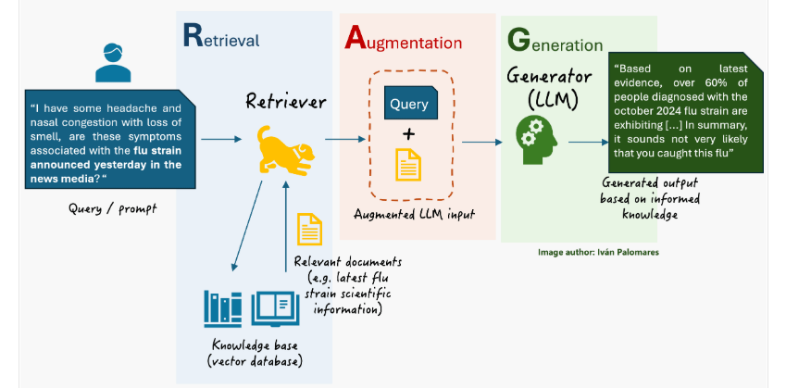

If the user asks a question in natural language to an LLM-based assistant endowed with an RAG engine, three stages take place between sending the question and receiving the answer:
- Retrieval: a component called retriever accesses the vector database to find and retrieve relevant documents to the user query.

- Augmentation: the original user query is augmented by incorporating contextual knowledge from the retrieved documents.

- Generation: the LLM -also commonly referred to as generator from an RAG viewpoint- receives the user query augmented with relevant contextual information and generates a more precise and truthful text response.

Inside the Retriever
The retriever is the component in an RAG system that finds relevant information to enhance the final output later generated by the LLM. We can mention it as an enhanced search engine that doesn’t just match keywords in the user query to stored documents but understands the meaning behind the query.
The retriever scans a vast body of domain knowledge related to the query, stored in vectorized format (numerical representations of text), and pulls out the most relevant pieces of text to build a context around them which is attached to the original user query. A common technique to identify relevant knowledge is similarity search, where the user query is encoded into a vector representation, and this vector is compared to stored vector data. This way, detecting the most relevant pieces of knowledge to the user query, boils down to iteratively performing some mathematical calculations to identify the closest (most similar) vectors to the vector representation of that query. And thus, the retriever manages to pull accurate, context-aware information not only efficiently, but also accurately.

Inside the Generator
The generator in RAG is typically a sophisticated language model, often an LLM based on transformer architecture, which takes the augmented input from the retriever and produces an accurate, context-aware, and usually truthful response. This outcome normally surpasses the quality of a standalone LLM by incorporating relevant external information.
Inside the model, the generation process involves both understanding and generating text, managed by components that encode the augmented input and generate output text word by word. Each word is predicted based on the preceding words: this task, performed as the last stage inside the LLM, is known as the next-word prediction problem: predicting the most likely next word to maintain coherence and relevance in the message being generated.

Fusion Retrieval
Fusion retrieval approaches involve the fusion or aggregation of multiple information flows during the retrieval stage of a RAG system. Recall that during the retrieval phase, the retriever -an information retrieval engine- takes the original user query for the LLM, encodes it into a vector numerical representation, and uses it to search in a vast knowledge base for documents that strongly match the query. After that, the original query is augmented by adding additional context information resulting from the retrieved documents, finally sending the augmented input to the LLM that generates a response.
By applying fusion schemes in the retrieval stage, the context added on top of the original query can become more coherent and contextually relevant, further improving the final response generated by the LLM. Fusion retrieval leverages the knowledge from multiple pulled documents (search results) and combines it into a more meaningful and accurate context. However, the basic RAG scheme we are already familiar with can also retrieve multiple documents from the knowledge base, not necessarily just one. So, what is the difference between the two approaches?
The key difference between classic RAG and fusion retrieval lies in how the multiple retrieved documents are processed and integrated into the final response. In classic RAG, the content in the retrieved documents is simply concatenated or, at most, extractively summarized, and then fed as additional context into the LLM to generate the response. There are no advanced fusion techniques applied. Meanwhile, in fusion retrieval, more specialized mechanisms are used to combine relevant information across multiple documents. This fusion process can occur either in the augmentation stage (retrieval stage) or even in the generation stage.
- Fusion in the augmentation stage consists of applying techniques to reorder, filter, or combine multiple documents before they are passed to the generator. Two examples of this are re-ranking, where documents are scored and ordered by relevance before being fed into the model alongside the user prompt, and aggregation, where the most relevant pieces of information from each document are merged into a single context. Aggregation is applied through classic information retrieval methods like TF-IDF (Term Frequency - Inverse Document Frequency), operations on embeddings, etc.

- Fusion in the generation stage involves the LLM (the generator) processing each retrieved document independently -including the user prompt- and fusing the information of several processing jobs during the generation of the final response. Broadly speaking, the augmentation stage in RAG becomes part of the generation stage. One common method in this category is Fusion-in-Decoder (FiD), which allows the LLM to process each retrieved document separately and then combine their insights while generating the final response.

Re-Ranking Works
In a re-ranking process, the initial set of documents fetched by the retriever is reordered to improve relevance to the user query, thereby better accommodating the user's needs and enhancing the overall output quality. The retriever passes the fetched documents to an algorithmic component called a ranker, which re-evaluates the retrieved results based criteria like learned user preferences, and applies a sorting of documents aimed at maximizing the relevance of the results presented to that particular user. Mechanisms like like weighted averaging or other forms of scoring are used to combine and prioritize the documents in the highest positions of the ranking, such that content from documents ranked near the top is more likely to become part of the final, combined context than content from documents ranked at lower positions.

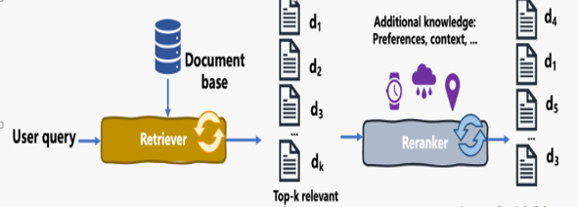

Re-ranking is one of the simplest yet effective fusion approaches to meaningfully combine information from multiple retrieved sources.
For example to better understand re-ranking, in the context of tourism in Eastern Asia. Imagine a traveller querying a RAG system for "top destinations for nature lovers in Asia." An initial retrieval system might return a list of documents including general travel guides, articles on popular Asian cities, and recommendations for natural parks. However, a re-ranking model, possibly using additional traveller-specific preferences and contextual data (like preferred activities, previously liked activities or previous destinations), can reorder these documents to prioritize the most relevant content to that user. It might highlight serene national parks, lesser-known hiking trails, and eco-friendly tours that might not be at the top of everyone's list of suggestions, thereby offering results that go “straight to the point” for nature-loving tourists like our target user.

